Exercise – Loop until Correct Value Input

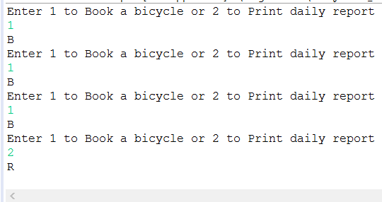

import java.util.Scanner;

public class BookorReport {

public static void main(String[] args) {
// TODO Auto-generated method stub

int userChoice;
Scanner in = new Scanner(System.in);
System.out.println("Enter 1 to Book a bicycle or 2 to Print daily report");
userChoice = in.nextInt();
do {
book();
System.out.println("Enter 1 to Book a bicycle or 2 to Print daily report");
userChoice = in.nextInt();
} while (userChoice != 2);
report();
}

static void book(){
System.out.println("B");
}

static void report(){
System.out.println("R");
}
}

