Calculating Car Depreciation

Maths Formula (Maths Model)

Compound interest formula A = P(1 - (^{R}/₁₀₀))^{N}

Graph (Visual Maths Model)
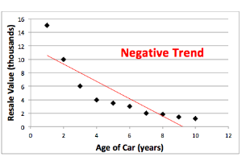

Graphical Maths Models
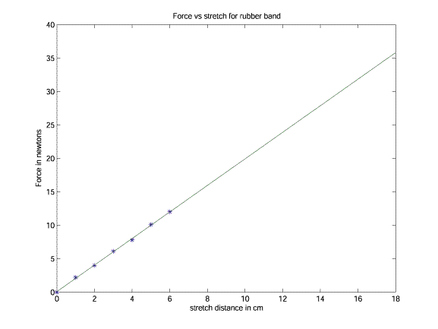

Using Graphs for Future Prediction

