Histograms
Question
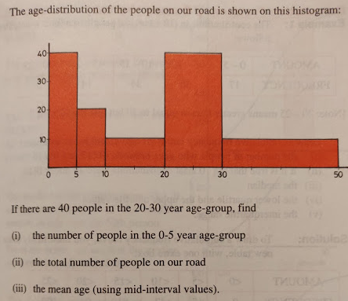

Answer
- 20
- 100
Mid-interval value | 2.5 | 7.5 | 15 | 25 | 40
x | 0_5 | 5_10 | 10_20 | 20_30 | 30_50
f | 20 | 10 | 10 | 40 | 20
 | 50 | 75 | 150 | 1000 | 800 | 2075
 | 20 | 10 | 10 | 40 | 20 | 100
 |  |  |  |  | Mean = | 20.75
- 20.75

